**7 Segment Display**

**Output:** <https://photos.app.goo.gl/qafPeawpfhDVRuQr9>

**Components:**

* Raspberry Pi
* Breadboard
* 7 Segment Display
* 74HC595
* Resistor (220Ω)
* Jumper wires
* 40-Pin GPIO Cable
* T-Extension Board

**Connections**:

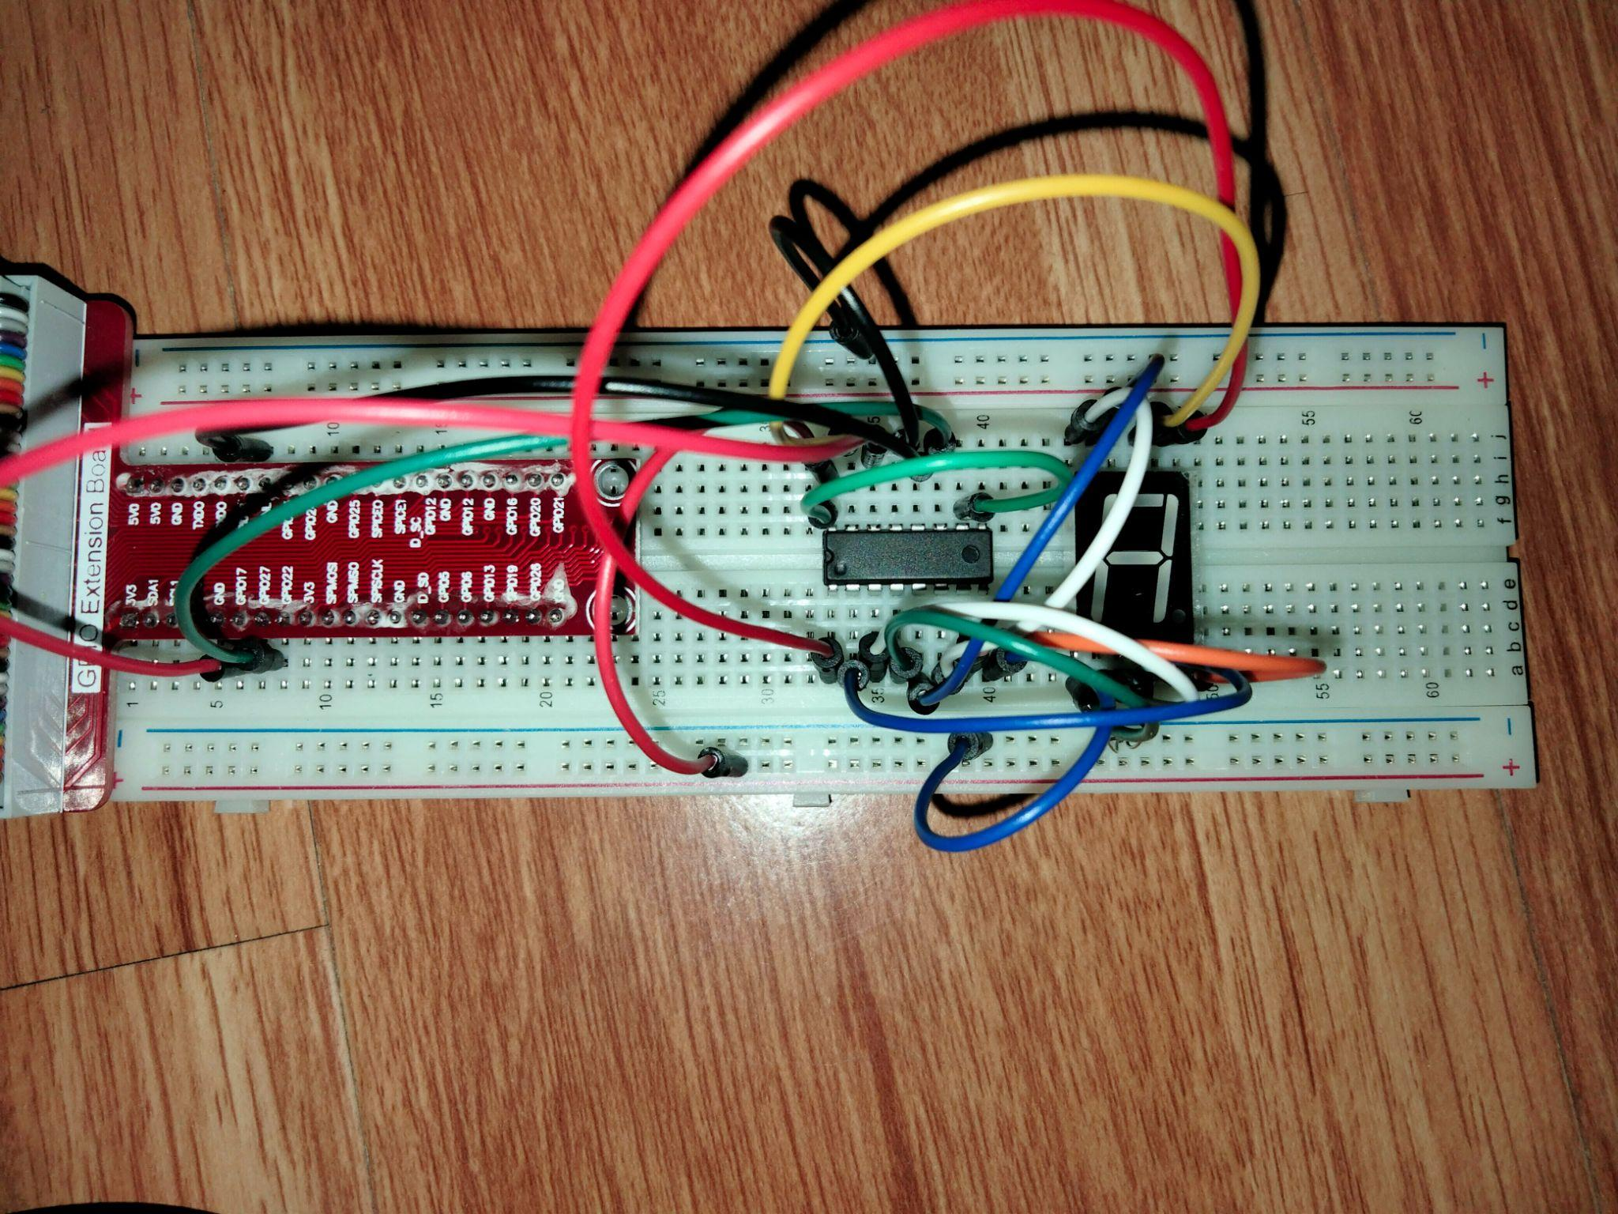

**Working:**

1. Once the wireless connection is established then open thonny Python IDE and open a new file.

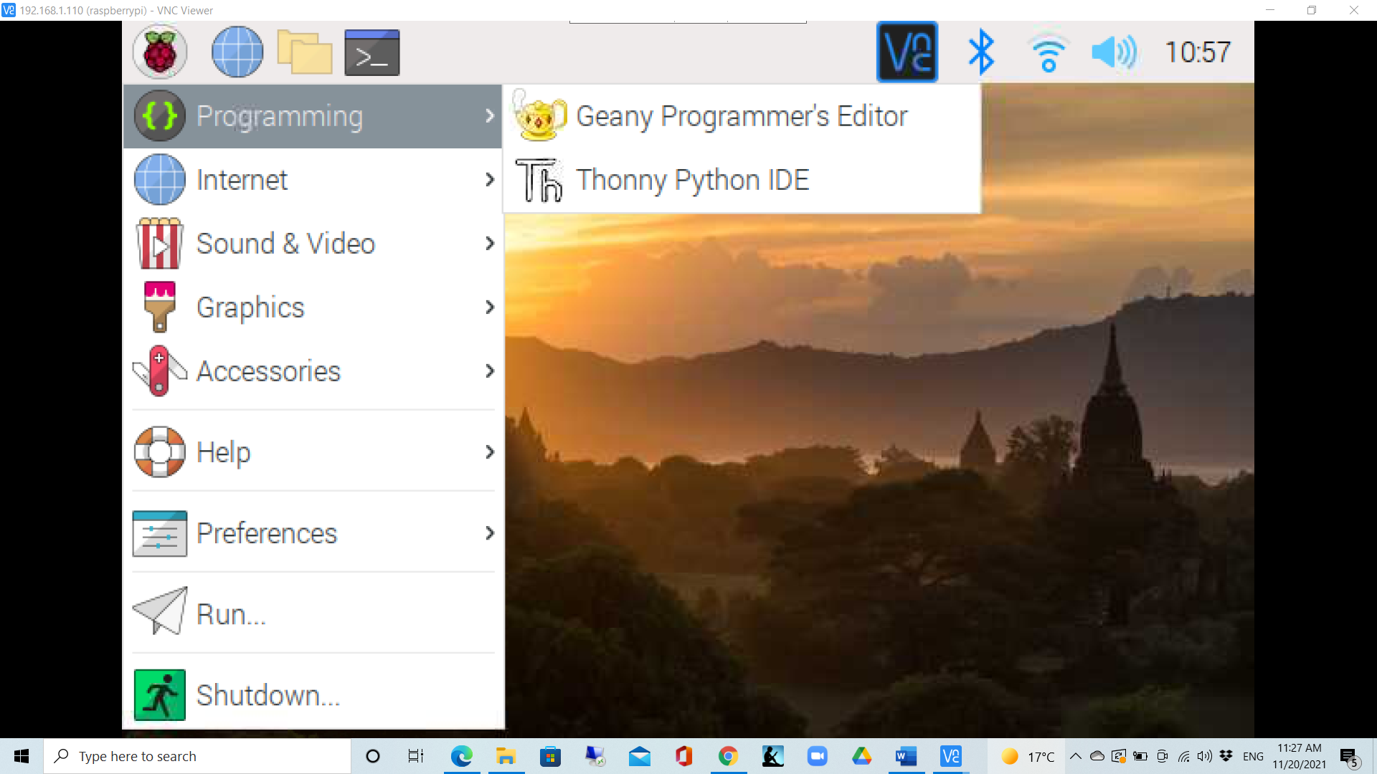

1. Type in the program and save as 7seg.py

**# Python Program**

import RPi.GPIO as GPIO

import time

SDI = 11

RCLK = 12

SRCLK = 13

segCode = [0x3f,0x06,0x5b,0x4f,0x66,0x6d,0x7d,0x07,0x7f,0x6f,0x77,0x7c,0x39,0x5e,0x79,0x71,0x80]

def print_msg():

print('Program is running...')

print('Please press Ctrl+C to end the program...')

def setup():

GPIO.setmode(GPIO.BOARD) #Number GPIOs by its physical location

GPIO.setup(SDI, GPIO.OUT)

GPIO.setup(RCLK, GPIO.OUT)

GPIO.setup(SRCLK, GPIO.OUT)

GPIO.output(SDI, GPIO.LOW)

GPIO.output(RCLK, GPIO.LOW)

GPIO.output(SRCLK, GPIO.LOW)

def hc595_shift(dat):

for bit in range(0, 8):

GPIO.output(SDI, 0x80 & (dat << bit))

GPIO.output(SRCLK, GPIO.HIGH)

time.sleep(0.001)

GPIO.output(SRCLK, GPIO.LOW)

GPIO.output(RCLK, GPIO.HIGH)

time.sleep(0.001)

GPIO.output(RCLK, GPIO.LOW)

def loop():

while True:

for i in range(0, len(segCode)):

hc595_shift(segCode[i])

time.sleep(0.5)

def destroy(): #When the program ends, the function is executed.

GPIO.cleanup()

print_msg()

setup()

try:

loop()

except KeyboardInterrupt:

destroy()

1. Run the program in command prompt as:

sudo python 7seg.py

1. Now you can observe the digits displaying on the 7-segment.